Manchester Deaf Centre - Room Hire Request Form

Person Enquiring / Booking
Company

Email

Phone Number

Date(s) Requested

Time(s) Requested

Room(s) Requested – Please delete / highlight as appropriate | Teddy Webb Hall (Large)  Teddy Webb Hall (Small)  Teddy Webb Hall (Whole)  Kitchen  Lounge  Meeting Room 2
Number of Attendees

Room Set Up / Layout – Please delete / highlight as appropriate | Blank Canvas  U Shape with tables  U Shape without tables  Boardroom  Theatre  Classroom  Other – please specify / discuss with MDC
Additional Requests (no extra cost!) – Please delete / highlight as appropriate | Wi-Fi  TV Screen / HDMI Cable for Laptops (not including APPLE devices)  Flip chart, paper and pens  Complimentary tea and coffee
Specific Requests

Catering Requests | We recommend our friends over at Open Kitchen Manchester! You can order from them directly, or we can take care of this for you for an additional fee – for more information please discuss this with our bookings team
Total Cost | For office use only

YOUR FINANCE DEPARTMENT DETAILS
Please provide the below details in order for Manchester Deaf Centre to invoice you for the services provided:

Finance Department Contact Name
Finance Department Address
Finance Department Email
Finance Department Phone Number
Purchase Order Number Required Y/N
MDC – Room Hire Fees and Additional Information
Room | Max Capacity | *Half Day Fee | *Full Day Fee | *Evening Fee | Weekend - Half Day | Weekend Full Day
Teddy Webb Hall Whole | 100 | £250 | £380 | £40 per hour | £100 | £200
+ Kitchen |  | £50 | £50 | £40 per hour | £50 | £50
Teddy Webb Hall Large | 50 | £180 | £250 | £40 per hour | £100 | £200
+ Kitchen |  | £50 | £50 | £40 per hour | £50 | £50
Teddy Webb Hall Small | 24 | £150 | £225 | £40 per hour | £100 | £200
Lounge | 27 | £150 | £225 | £40 per hour | £100 | £200
Youth Space | 47 | £150 | £225 | £40 per hour | £100 | £200
Meeting Room 2 | 22 | £150 | £225 | £40 per hour | £100 | £200

*Half day fee refers to any booking between 1-4 hours (e.g. 9am-1pm / 1pm-5pm)

*Full day fee refers to any booking between 4-9 hours (e.g. 9am-6pm)

*Evening fee refers to any bookings for after 6pm
*Please note: max capacity may vary in line with COVID-19 related government guidelines at the time of booking
*Discounts: if you are making a block booking of more than 6, or booking more than 1 room, you may be eligible for a discount. You can discuss this with our bookings team
Also available to hire: Riley’s bar
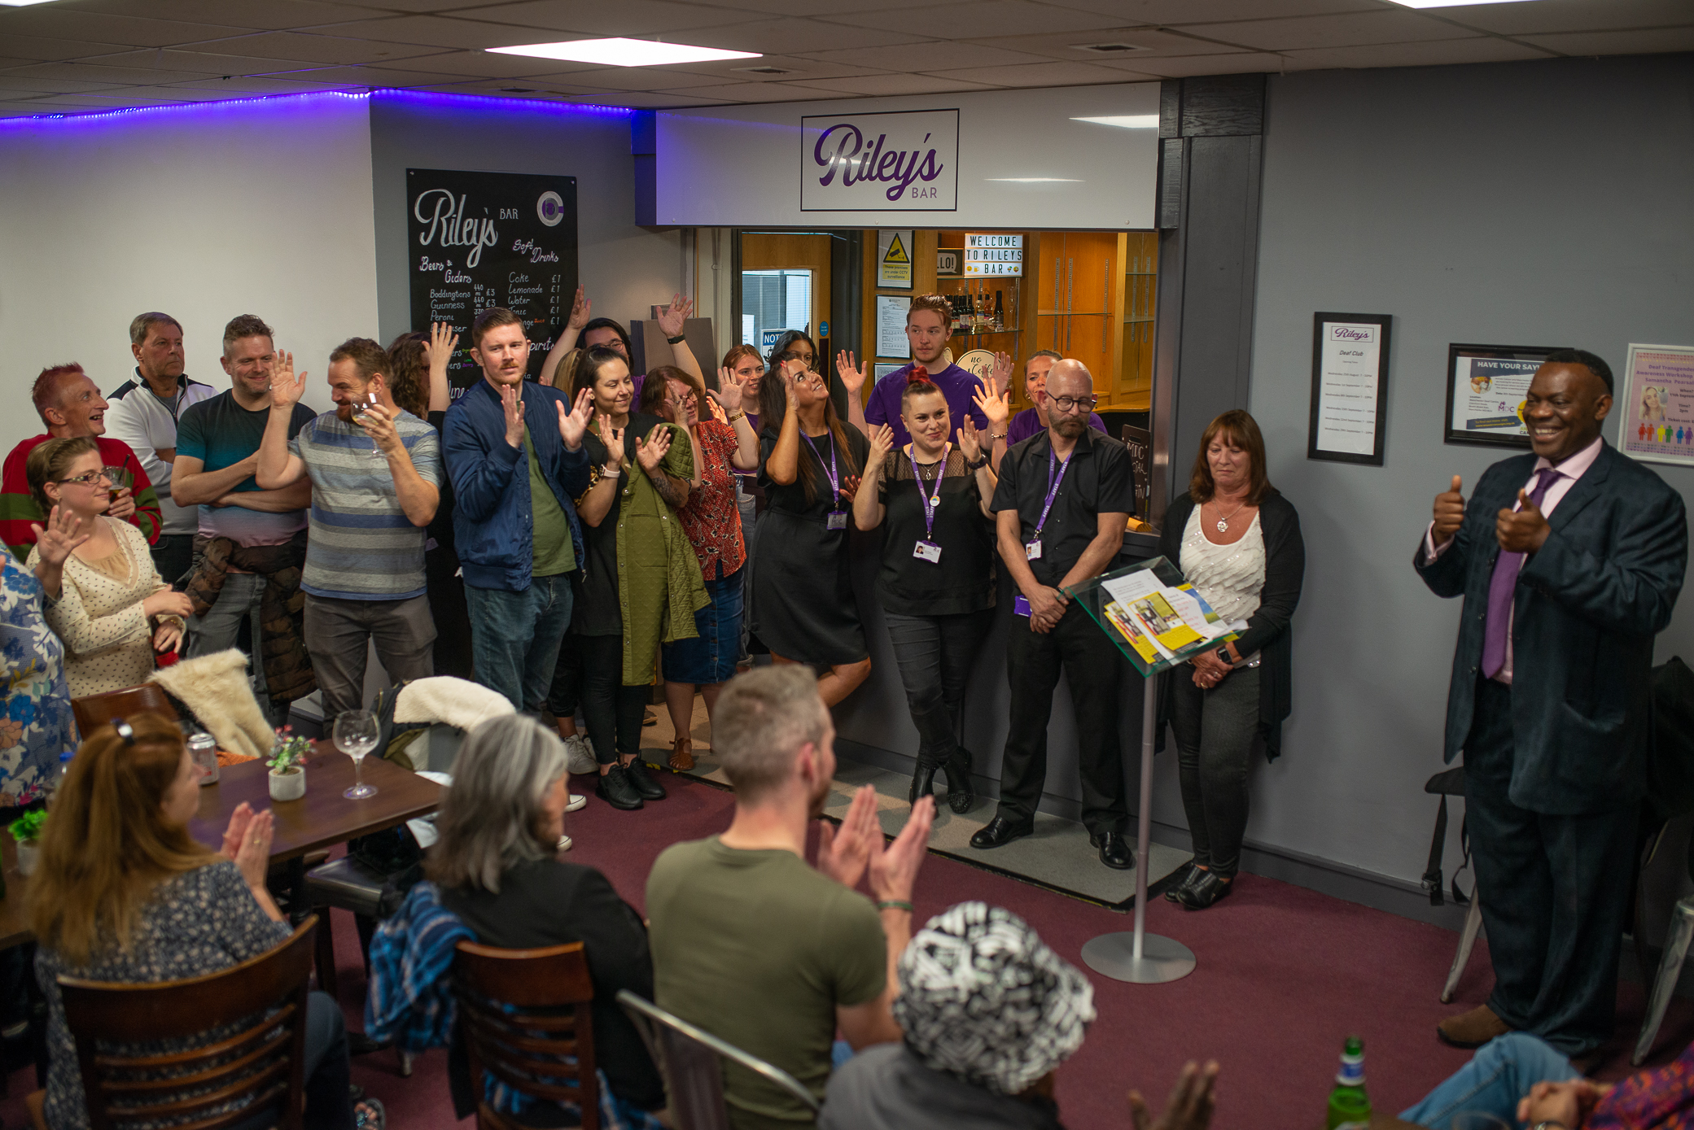
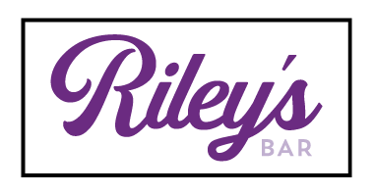
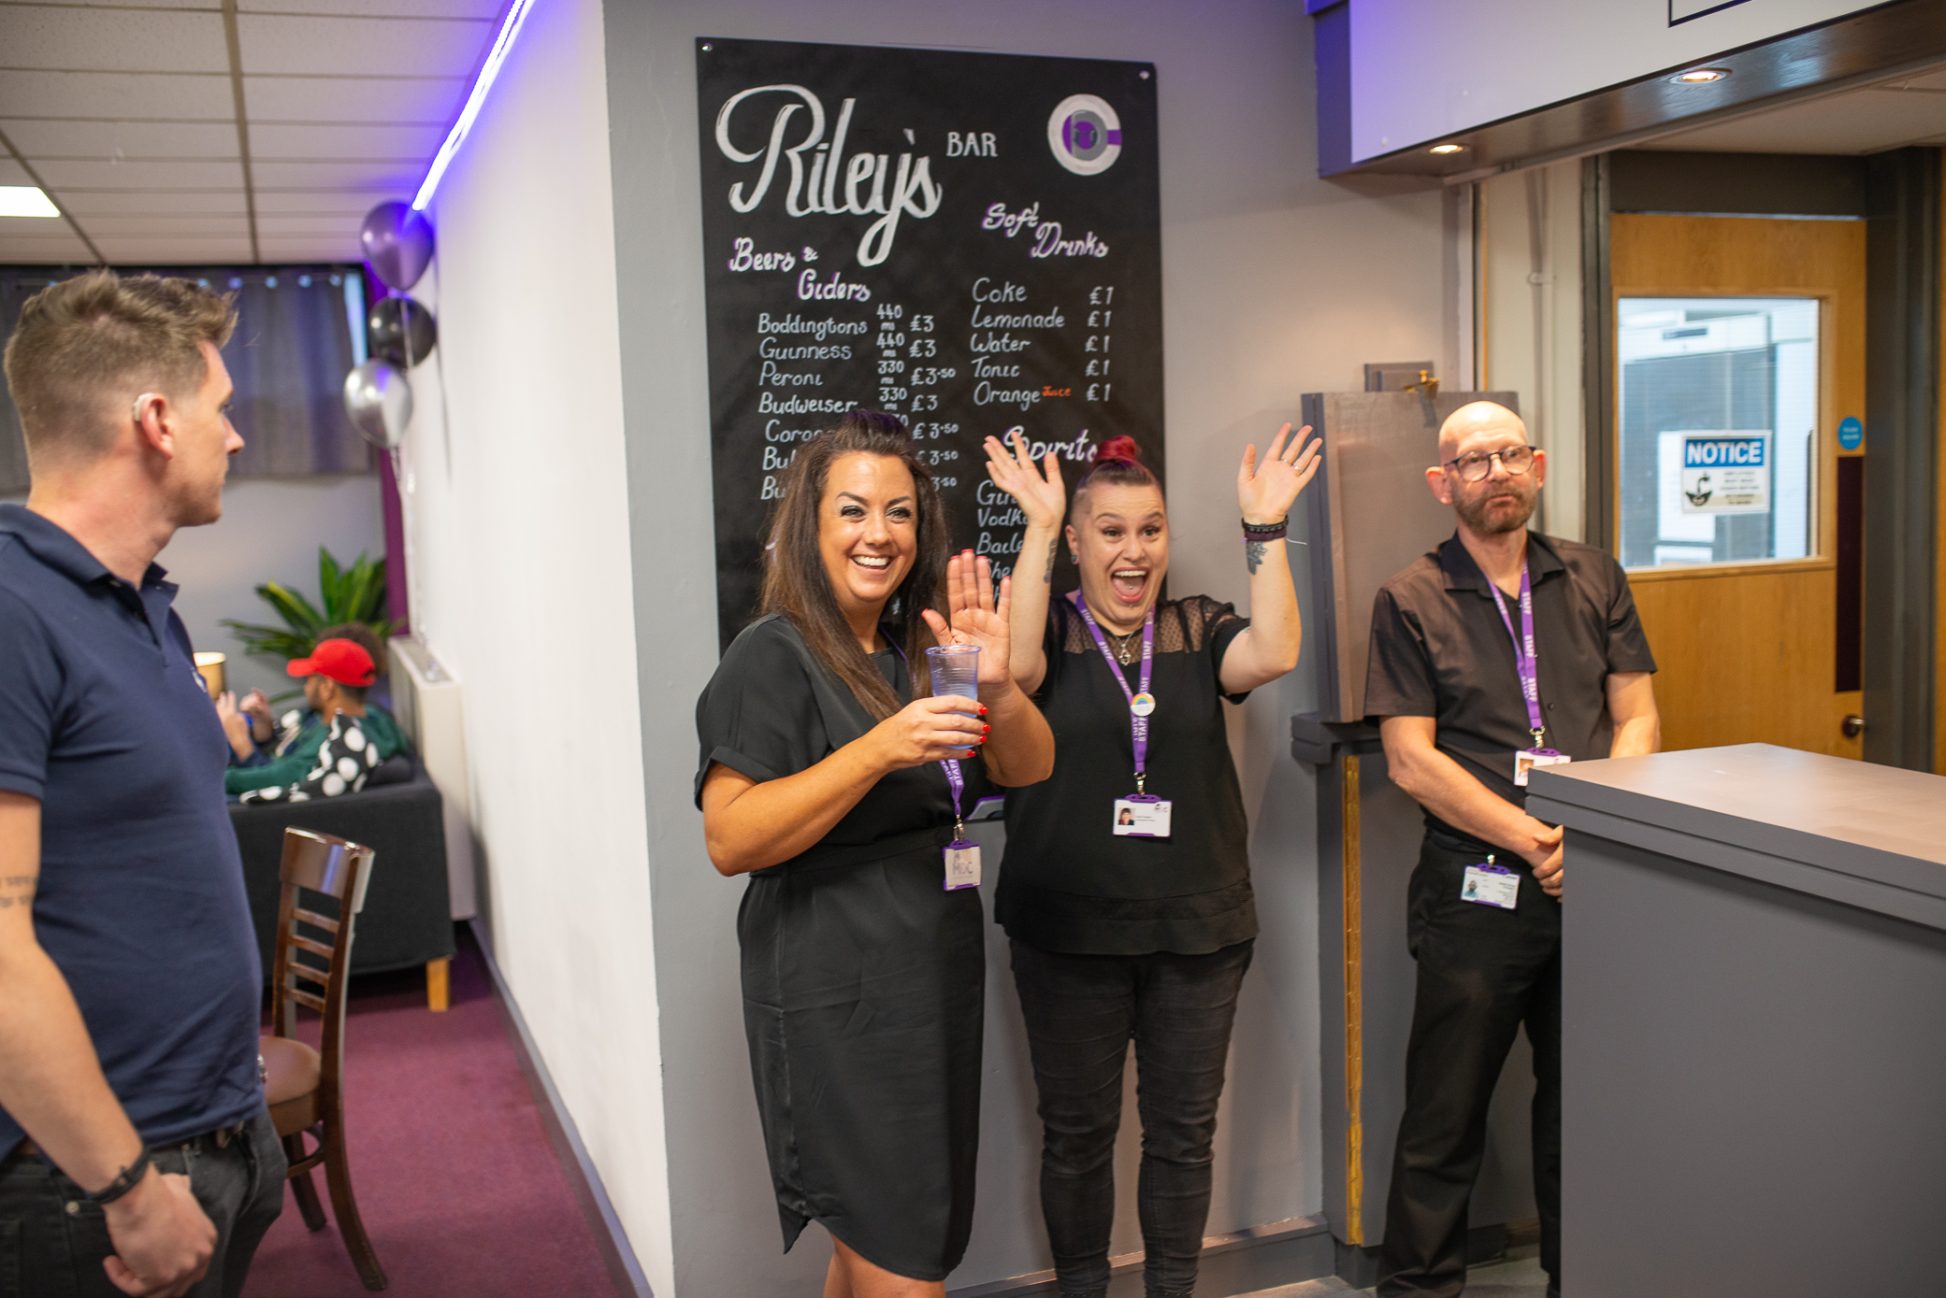

Manchester's only fully accessible and deaf friendly bar in the heart of the city. Riley’s is perfect for staff events and personal parties and can be opened to serve refreshments if you are having an event at MDC. Please talk to our bookings team about opening Riley’s and the additional fees associated with this. We are happy to discuss and try to accommodate any requests you may have! You can also follow us on Instagram @rileys_bar_mcr

Cancellation Terms and Conditions
15 days’ notice or more before the booking date: no cancellation fee
8-14 days’ notice before the booking date: 50% cancellation fee
1-7 days’ notice before the booking date: full charge applies

Facilities and Parking

Our Location
MDC is in a fantastic location, centrally located with easy access to popular bus routes. Only a 10-minute walk from Oxford Road train station and St. Peter’s Square Metrolink. For those travelling by car, the Aquatics Centre car-park is situated on Booth St East, just a 2-minute walk from MDC. The building is wheelchair accessible and has a lift which enables access to all areas of the building.

Our Rooms

We have various rooms available for hire at MDC with varying capacities. All rooms have access to screens (perfect for delivering presentations or information sharing), all rooms are wheelchair accessible, have air conditioning and can be set up in various styles per the client’s request. We can facilitate bookings from 12 participants up to 100 participants. Our rooms can facilitate meetings, workshops, interviews, training sessions, cooking lessons (as we have a fantastic kitchen available for hire as well), charity events, the list is endless! If you need a room, our helpful admin staff are always available to discuss your requirements and advise which room would be best suited to your needs.

Additional Services

Require a BSL interpreter, lip speaker or note-taker at your event? Contact our bookings team on 0161 273 6699 or email bookings@manchesterdeafcentre.com and we will happily assist.

