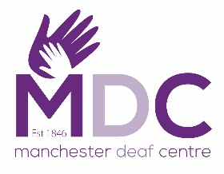
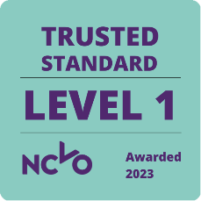
*Please complete and return to reception
MDC Membership Form

Surname:
Forename(s): | Preferred Name (if applicable):
Title: | Male / Female/ Prefer not to say
Contact Information
House Number:
Postcode:
Preferred Mode of Communication: | □ British Sign Language (BSL)  □ Sign-Supported English (SSE)  □ Oral (speech/lipreading) | □ Deaf-blind manual  □ BSL Visual Frame  □ Other: ______________

Preferred method of communication:

Text Email Videophone Other ___________________________

If you tick a box, please provide the email address or phone number _________

I give consent to be photographed by Manchester Deaf Centre for fundraising, publicity or other purposes to help achieve the group’s/Centre’s aims. This might include (but is not limited to), the right to use them in their printed and online publicity, social media, press releases and funding applications.
Yes No

Signature _______________________________________________

Date______________________________________________

